**Cross curricular: PSHE-Team**

* I can talk about changes and how they might make me feel.
* I can pay attention to and respond considerately to others.

**Cross Curricular: Reading: I survived the Japanese Tsunami in 2011 (Lauren Tarshish).**

Develop subject knowledge, structure and vocabulary.

**NC Objectives:**

* Maintain positive attitudes to reading and understanding of what he/she reads by reading books that are structured in different ways
* Apply the knowledge of root words, prefixes and suffixes both to read aloud and to understand the meaning of new words
* To understand the authors choice of words and structure

**Cross Curricular: Writing:**

* Setting description – To describe a Tsunami setting
* Diary Entry- Survivor of the Japanese Tsunami in 2011.

**NC Objectives:**

* To write and draft by composing sentences, building a rich and varied vocabulary
* Draft and write by organising writing into paragraphs as a way of grouping related materials
* In narratives, create settings, characters and plot
* Evaluate and edit by assessing the effectiveness of his/her own writing

**YEAR 3 – Autumn Term 2 Planning – Why is the earth so angry? (Geography)**

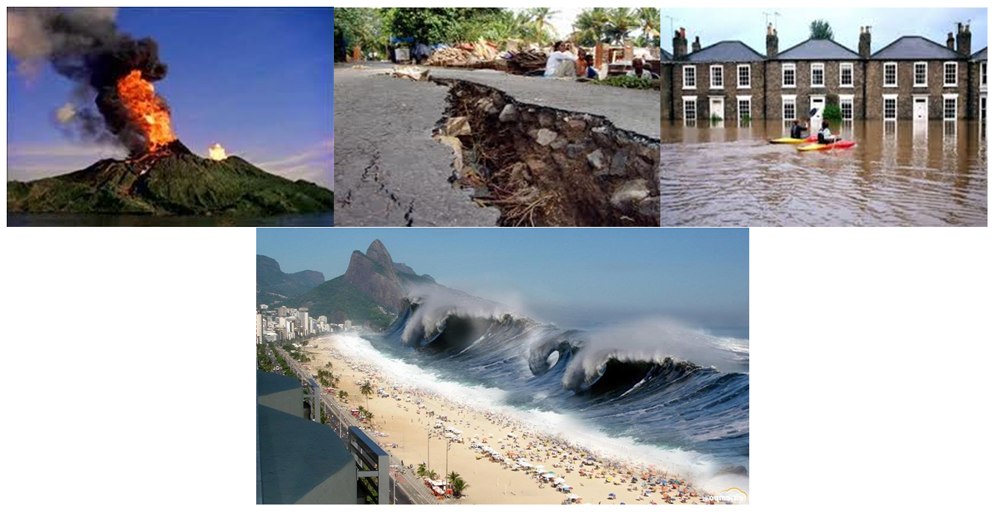

**NC Skills:**

**Geographical skills and fieldwork:**

* **Use maps, atlases and digital/computer maps to locate countries which are at a higher risk of experiencing earthquakes and/or volcanoes**
* **To understand and use a widening range of geographical terms e.g. specific topic vocabulary**

**Locational Knowledge:**

* **Know where tectonic plates and the ring of fire lay**
* **Locate places in the world where volcanoes occur.**

**Human and physical geography:**

* **Describe and understand key aspects of:**

**physical geography including: volcanoes, earthquakes, tsunamis and tornadoes**

* **Discuss how volcanoes and other natural disasters affect human life including: damage to infrastructure, advances in science to predict natural disasters, methods of prevention and rescue aid.**
* **Understand and be able to communicate in different ways the cause of some natural disasters and the process that occurs before they happen.**

**Cross Curricular: Science:**

**Forces-** Volcanoes need a lot of force behind them to make them shoot into the air and then gravity causes the lava to return to the ground.

NC Objectives:

* Compare how things move on different surfaces
* Notice that some forces need contact between 2 objects, but magnetic forces can act at a distance

**Cross Curricular: SMSC**

* Reflect upon similarities and differences when exploring different places therefore considering different ways of living in different places and different/ similar perspective on life.
* Share ideas/ experiences that are close to home (e.g. local area) to further afield.
* Understanding the consequences of behaviours and actions. (When considering physical topics such as rivers, flooding and coasts; consideration is given to how much these issues that arise are man-made and is because of exploitation).
* are man-made and is because of exploitation.
* coasts; consideration is given to how much these issues that arise
* are man-made and is because of exploitation.

**Cross Curricular: Music** **Links**

Composing and performing- The sound of Natural Disasters

**NC Objectives:**

* Create simple rhythmic patterns,
* Recognise and musically demonstrate awareness of a link between shape and pitch using graphic notations, physical movements etc

**Cross Curricular: Art/DT**

**Observational drawings- The Great Wave by Hokusai**

**NC Objectives:**

* To develop intricate patterns/marks with a variety of media.
* To demonstrate experience in different grades of pencil and other implements to draw different forms and shape.
* To know about some of the great artists, architects and designers in history and describe their work (Hokusai)