L.O. To divide by a 1-digit number
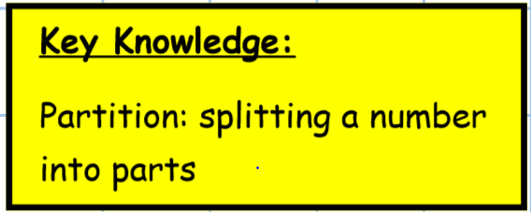
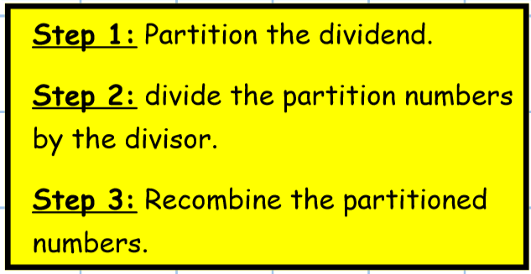
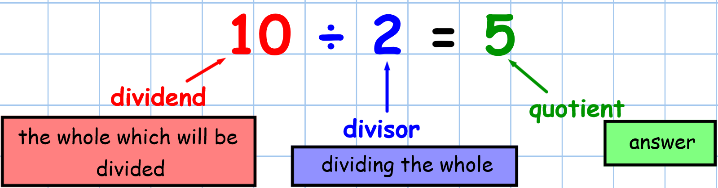
Main Task: Solve these calculations by dividing by partitioning.
- 48 $÷$ 2 =

- 39 $÷$ 3 =

- 69 $÷$ 3 =

- 55 $÷$ 5 =

- 96 $÷$ 3 =

