1. **Colour multiples of 4.**

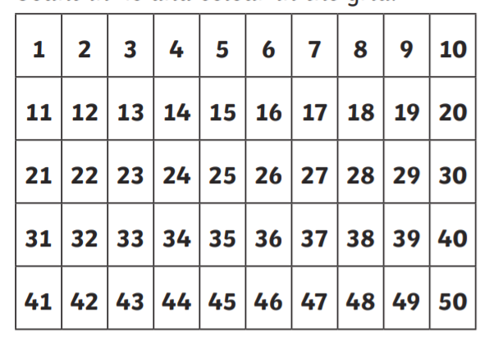

1. **Complete the number sentences below:**

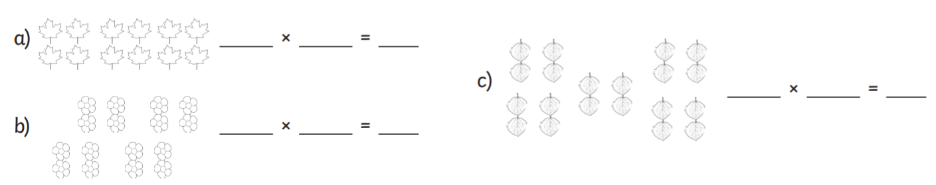

1. **Answer the questions below:** 