L.O. To explore division strategies

Main Task:
- 400 $÷$ 10 =

- 700 $÷$ 100 =

- Share these apples between 4 people.

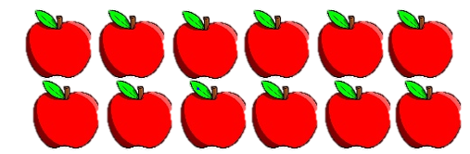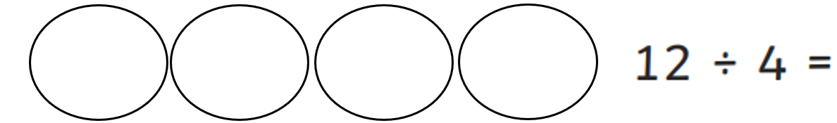

- There are 15 cubes. 3 cubes must be put into a group.
How many groups will there be?
Draw the groups with 3 cubes in each group. The first one has been done for you.
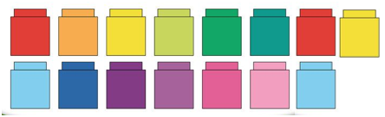
How many groups are there?

- 14 $÷$ 2 = 18 $÷$ 2 = 21 $÷$ 3 =

20 $÷$ 4 = 22 $÷$ 2 = 30 $÷$ 3 =

