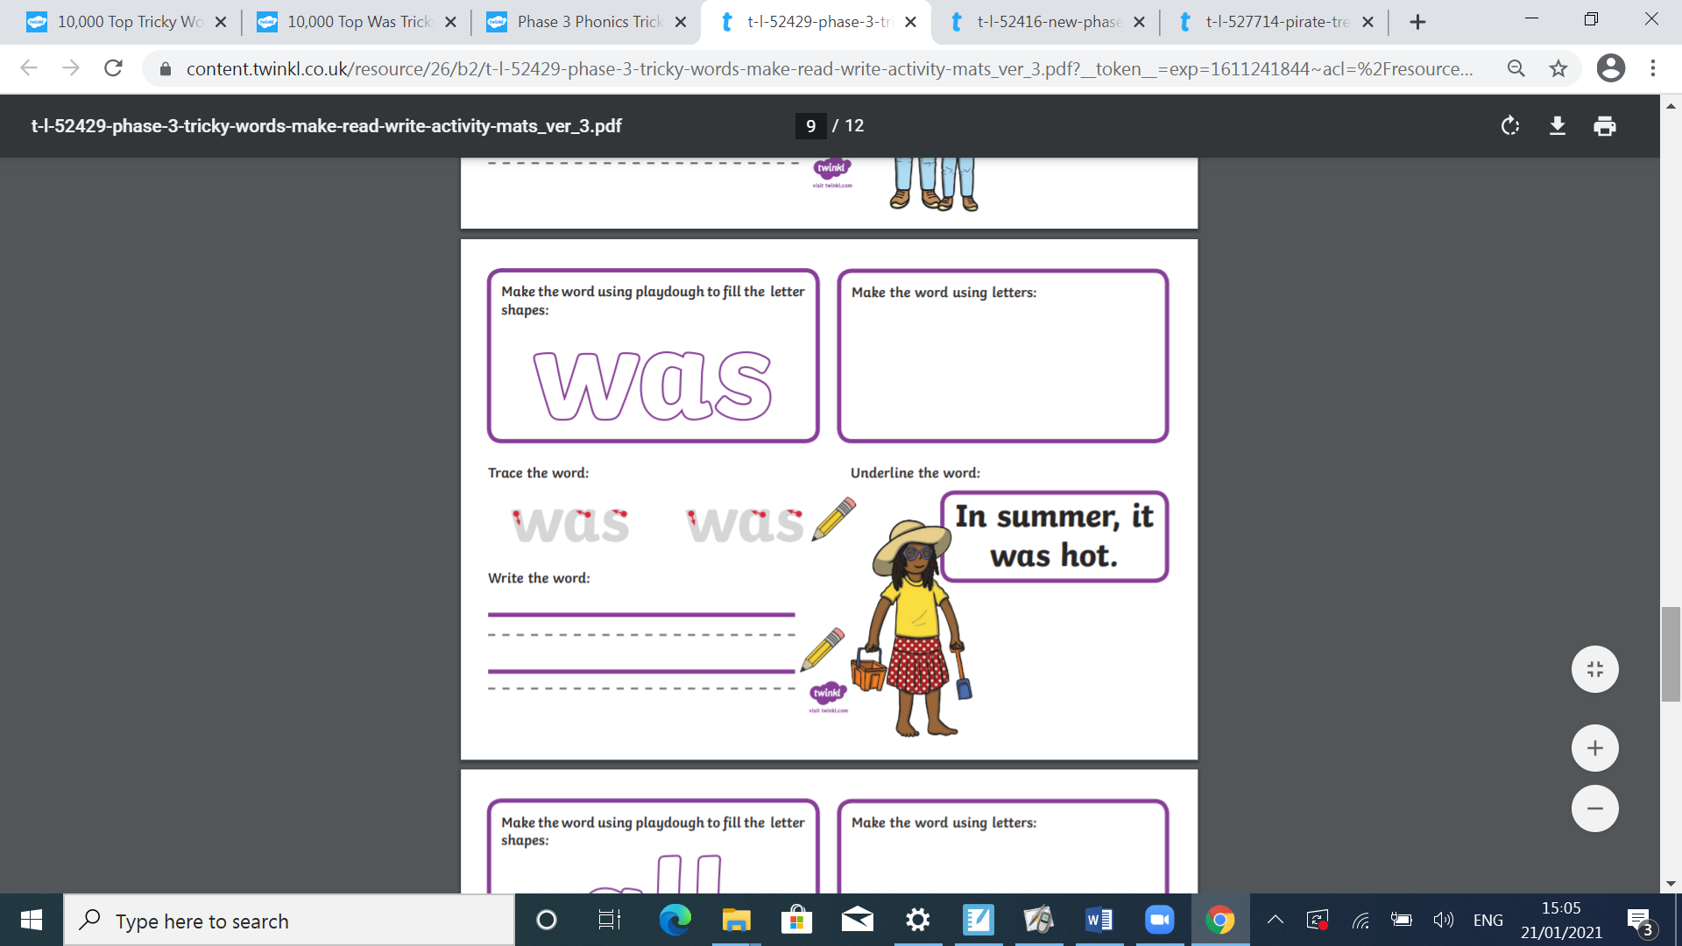

Colour and decorate the words

**are**

**are**

**are**

**are**

**are**

**are**

**are**