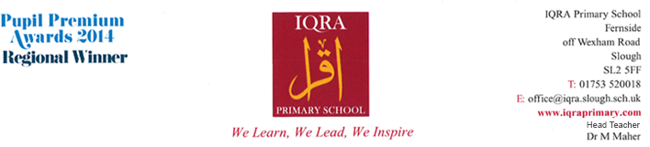
Required February 2021
Home School Liaison Officer
Salary Level 6 SCP 30-35 ● 32.5 hours per week, term time plus 5 Inset Days ● Pro Rata Annual Salary Range Inclusive of LW £21,710 - £25,592
Initially one-year fixed term contract

Do you want to make a difference? We are looking for enthusiastic and flexible staff members to work within our well established, thriving and lively team.

The main role will be to provide the vital family support link between school and children/families to serve the needs of young people who are experiencing emotional and behavioural difficulties. You will be responsible to:
- Promote integrated working between school and specialist services whilst liaising with other agency professionals
- Community cohesion – links with community/businesses/schools
- Be involved in supporting events across the school which will include leading on fundraising initiatives/building up a school PTA
- Be the point of contact for parents/develop a parent support group
- Bilingual interpreter – occasionally for parent/carer meetings
- Attendance Lead – overseeing and managing whole school attendance
- Co-ordinating and writing the School Newsletter

Candidates must have:
- Relevant professional qualification in Health, Social Care, Youth Work, Community Development or Education
- Child Protection/Safeguarding Training (Level 1 minimum)
- Demonstrate a high level of written and spoken English
- Experience of attendance although training will be given

We offer:
- A positive and caring ethos and working atmosphere
- Friendly children, eager to learn and achieve
- A committed, enthusiastic and supportive staff team
- Excellent support from the Governing Body, the staff and parents
- An excellent opportunity for professional and career development

If you have the enthusiasm and commitment to contribute to the ongoing development of this successful, friendly and supportive school, we would like to hear from you.

IQRA Primary School is committed to safeguarding and promoting the welfare of children, young people and vulnerable adults. We expect all staff and volunteers to share this commitment. An enhanced DBS disclosure will be required for the successful candidate in accordance with Safeguarding Children and Safer Recruitment in Education Legislation.

For an application pack please visit the school website or contact Susan Anderson at pa@iqra.slough.sch.uk. Please note that CVs are not accepted.

Closing Date: 18th January 2021

