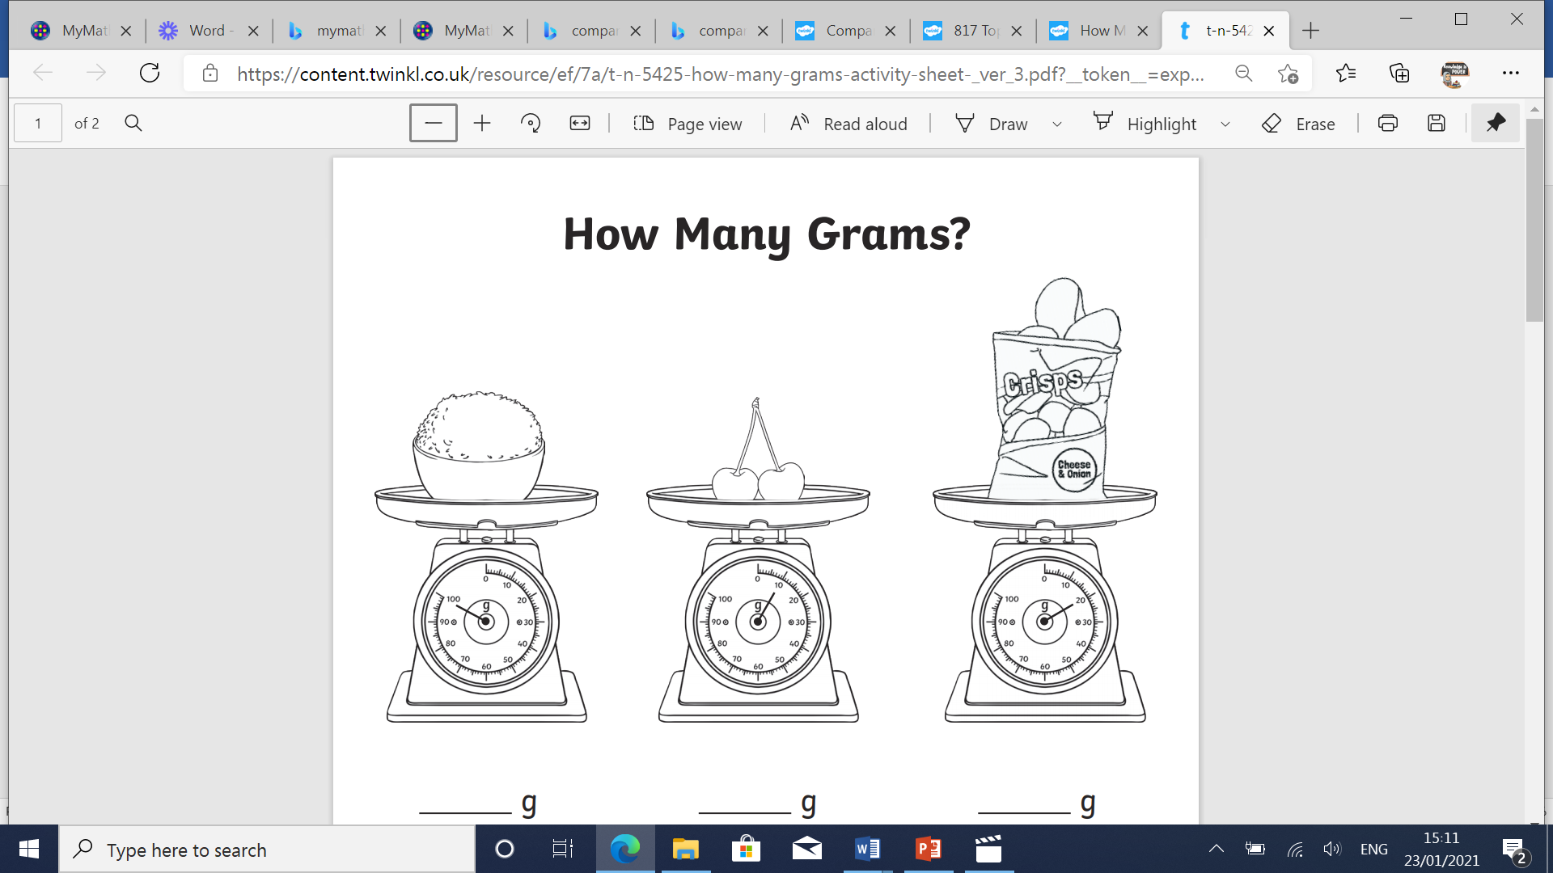

**Which is the heaviest? _______________________________**

