Tuesday 6th October 2020
LO: To describe a character's appearance.

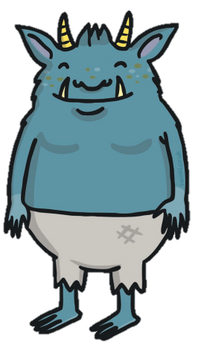

Key Vocabulary:
horns
head
eyes
ears
teeth
arms
feet
hands

Colour: blue yellow
Number: one two
Size: big, small
Feel: furry, sharp

