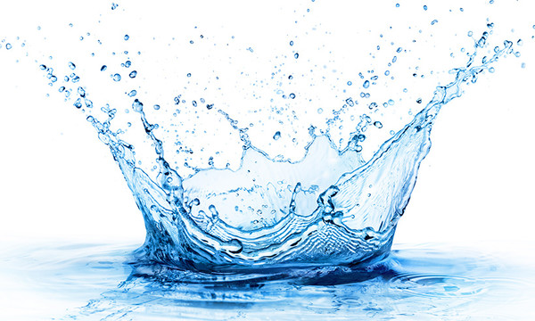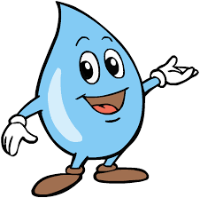

How will you use water responsibly?



How will you use water responsibly?



How will you use water responsibly?