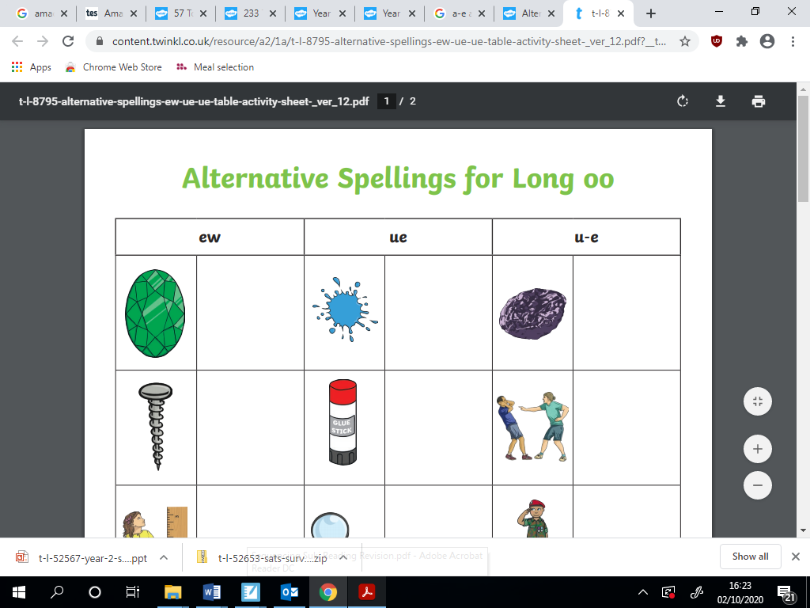

1

**Number these events in the order in which they happened in the story.**

**The first one has been done for you.**

Grace went to school and Raj said she can’t be Peter pan.

Grace loved listening to stories.

Grace and her grandma went to the ballet.

Mum was angry at what Raj said.

All the children voted for Grace to be Peter Pan.