LO: To describe a character's appearance.

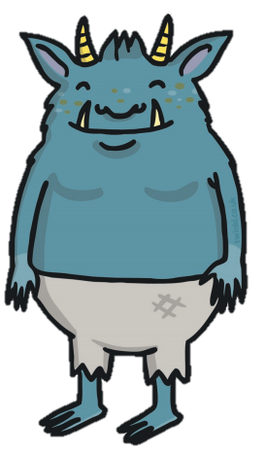
Now use your brainstorm to write about the character’s appearance

