25.09.20
LO: To match one object with another- One - to - one correspondance
Are there enough bowls for the bears? | Are there enough plates for each cake?
Six children are going to the beach. Are there enough caps for everyone?  How many more caps are needed? | Five dogs need to go for a walk. Are there enough collars? Explain your answer.  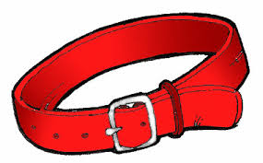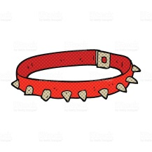  How many more collars are needed?

