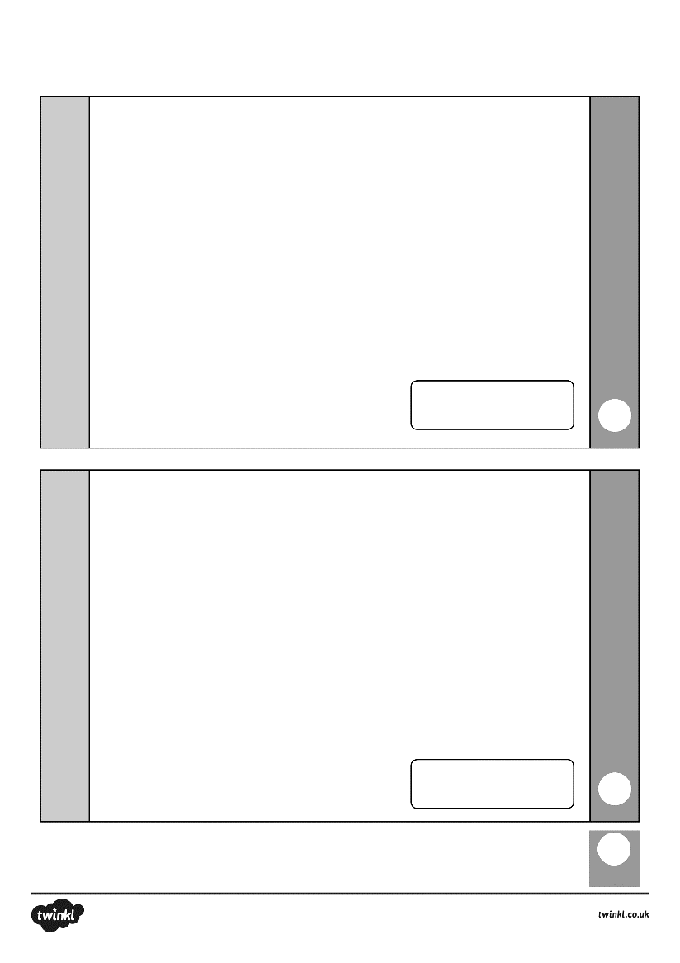
LO: To add multiples of 10
14 + 10 = ____
38 + 40 = ____
18 + ___ = 88
10 + 40 + 30 = ____
3 + 7 + 10 = ____
___ + 20 = 56
Starter

