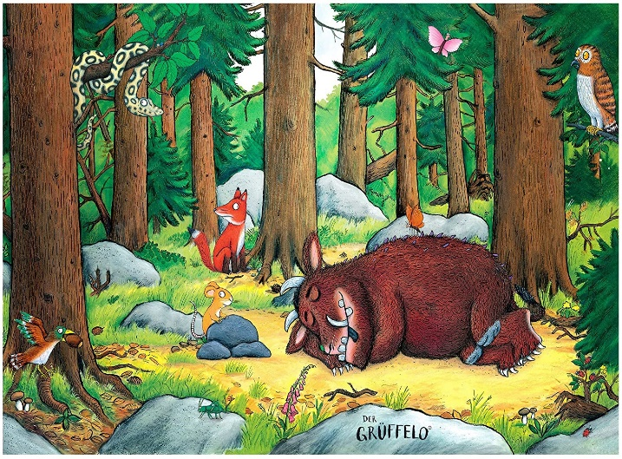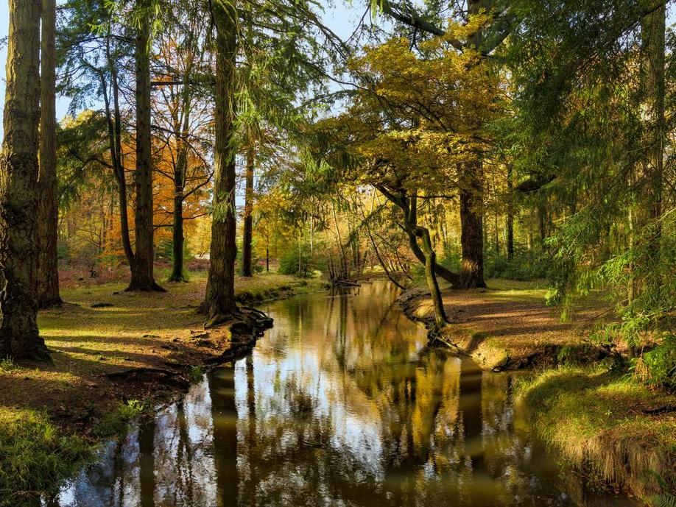

**Prepositions**

above

across

against

behind

below

opposite

towards

underneath

on top

**Key words**

chirping

creaking

damp

rough

rotting

swaying

rustling

branches

squirrels

relaxing

**Topic key words**

people

climb

grass

wildlife

rural

**because**

Behind….

Underneath…

Next to….

Suddenly…

**Sentence starters:**

If you look closely…

However…

Although …

Out of the blue…