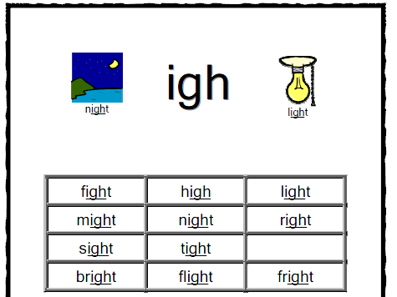

Read the words and write some sentences which include an ‘igh’ word.

________________________________________________________________________________________________________________________________________________________________________________________________________________________________________________________________________________________________________________________________________________________________________________________________________________________

