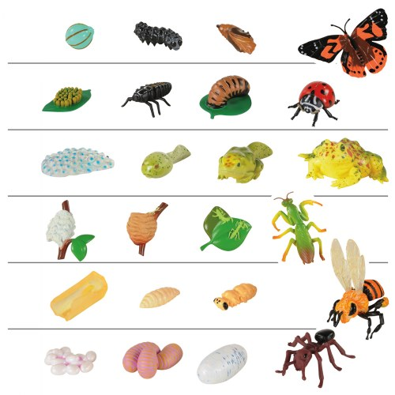

**Enquiry Question: How do animal life cycles vary?**