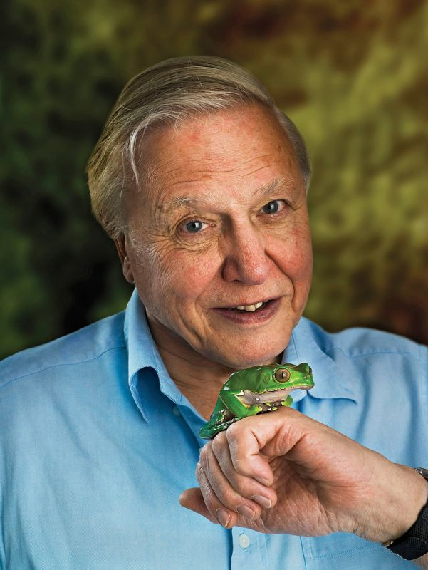

**Enquiry Question: How does the work of naturalists impact the scientific community?**



**Enquiry Question: How does the work of naturalists impact the scientific community?**



**Enquiry Question: How does the work of naturalists impact the scientific community?**



**Enquiry Question: How does the work of naturalists impact the scientific community?**



**Enquiry Question: How does the work of naturalists impact the scientific community?**