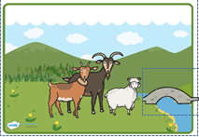Word bank – Three Billy Goats Gruff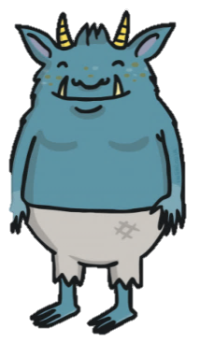

Characters – small/medium/big Billy Goat Gruff, Troll

|  |  |  |
| --- | --- | --- |
| hill, valley | small, two, deep | lived |
| field, grass | sweet, green | grew  **Sentence Starters**  In the valley,  Between two hills  Under the bridge,  First,  Next,  Then,  He felt …  Suddenly… |
| bridge | small, stone | crossed, walked |
| river | wide, fast | flowed |
| troll | blue, bad, hungry  evil, angry, scary | said, grunted  roared, growled, |
| biggest goat | strong, heavy | shouted, lowered, charged, butted |

