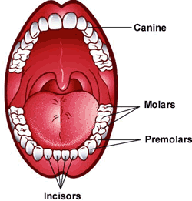
Types of teeth

You've probably noticed that you have different types of permanent teeth in your mouth. Each one has its own function.
Your two front teeth and the teeth on either side of them are incisors. There are four on the top and four on bottom.
Incisors are shaped like tiny chisels, with flat ends that are somewhat sharp. These teeth are used for cutting and chopping food. Think back to that apple you ate: You used your incisors to crunch into the skin of the apple.
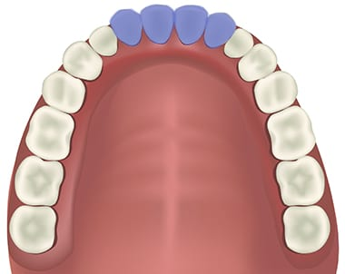
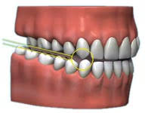
The pointy teeth beside your incisors are called canine teeth. There are four of them, two on top and two on bottom. Because these teeth are pointy and also sharp, they help tear food.

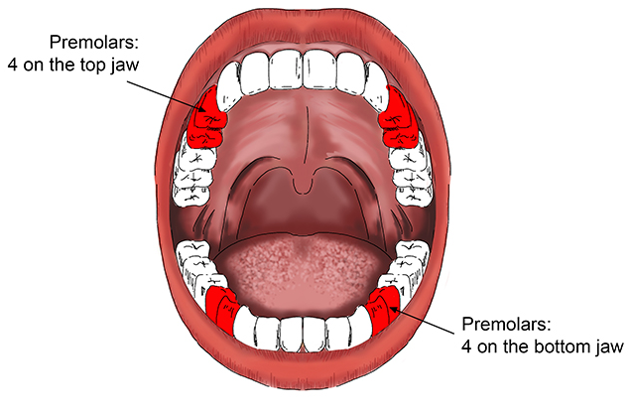
Next to your canine teeth are your premolars, which are also called bicuspid teeth. You have eight premolars in all, four on top and four on the bottom. You'll need to open a bit wider to see these teeth, but when you do, you'll notice that their shape is completely different from both incisors and canines. Premolars are bigger, stronger, and have ridges, which make them perfect for crushing and grinding food.

If you open your mouth really wide, you'll see your molars. You have eight of these, four on the top and four on the bottom. Sometimes these are called your 6-year molars and your 12-year molars because that is around the time when they come in.
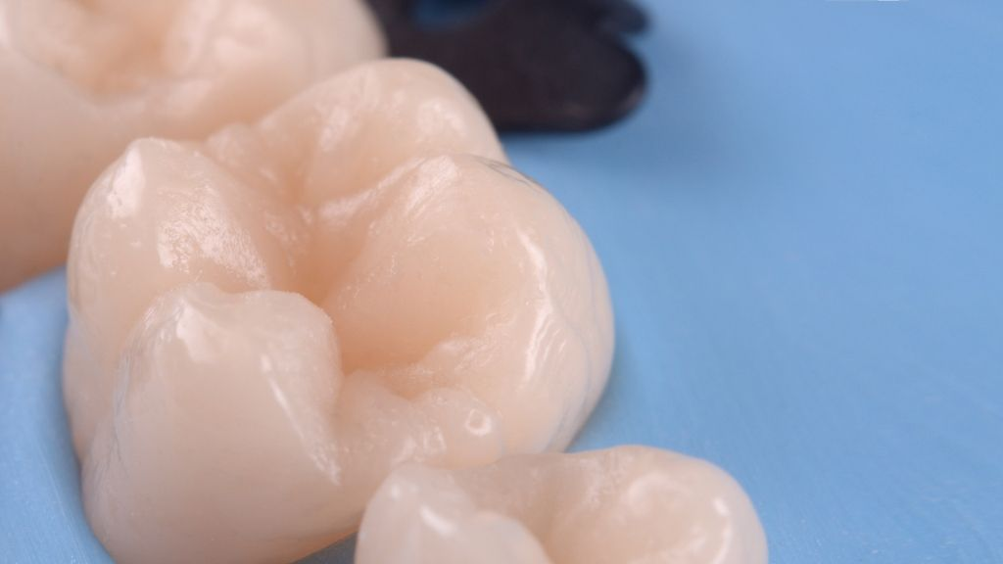
Molars are the toughest of the bunch. They are even wider and stronger than premolars, and they have more ridges. Molars work closely with your tongue to help you swallow food. How? The tongue sweeps chewed-up food to the back of your mouth, where the molars grind it until it's mashed up and ready to be swallowed.

