Tudor houses were built during the Tudor era in England between 1485 – 1603 and they had a very distinctive black-and-white style appearance. The Tudor period is the time when the Tudor family came to the throne in England from 1485 – 1603. One of the most famous members of the Tudor family is King Henry VIII. There are still a large number of Tudor house in the UK and some of them are more than 500 years old.
See the fact file below for more information on Tudor Houses or alternatively download our comprehensive worksheet pack to utilise within the classroom or home environment.

What Do Tudor Houses Look Like?
The majority of homes in Tudor times were half timbered. This means that they had a wooden frame and the spaces between were filled with small stick and wet clay. This was called wattle and daub.
The most distinctive feature of Tudor houses was their ‘black-and-white’ effect. See the images below for examples of real Tudor houses.

Facts About Tudor Houses
- The distinctive black and white look on most Tudor houses is because of the exposed wooden frame. Some of the Tudor homes in the UK are still privately owned and lived it, some are small museums that you can take a tour of, and some have been converted into hotels.
- Most houses had the wooden frame, as well as a tall chimney, steep roof and an enclosed fireplace inside. The walls between the timber frame were made from wattle and daub – wood strips or sticks covered with clay – and the outer walls were most often whitewashed.
- Many Tudor houses had thatched roofs. However, for those who were rich enough to afford it, a tiled roof was also available which was more weather-proof and durable than a thatched roof.
- Tudor homes often had some kind of garden as well. For people with less money, a garden would be quite small and was a place where they could grow their own herbs and vegetables. People with more money would have a large garden and this might include more elaborate decoration. Mazes, fountains, or hedges shaped like animals were not uncommon.
- Most Tudor houses did not have a toilet. A toilet in Tudor times was called a privy and despite its name it wasn’t as private as it is today. People in Tudor times would go to the toilet anywhere – in the streets, the corner of a room or even a bucket. Some castles and palaces did have toilets, but it was really just a hole in the floor above the moat.
- When people moved house, they would take their windows with them. Glass was expensive during the late 15th century, and since only a few people could afford to buy it, they would take it with them when they moved.
- Tudor furniture in the home was big, heavy, uncomfortable and usually made of oak. Instead of chairs, people would sit on wooden benches or stools.
- Only rich people could afford carpets. It seems strange today, but those who could afford carpet actually hung it on the wall instead of placing it on the floor. Most houses had dirt floors that were impossible to clean so they would cover it with reeds or rushed to hide it.
- Some Tudor houses had upper storeys bigger than the ground floor. This was called a jetty and it’s when the upper storeys would overhang. The origins of the jetty are not known but in a town it was very useful for enlarging floor space while getting maximum street width.
- People used to throw their rubbish out of the window into the street. This was common in Tudor times for the streets to contain a lot of rubbish from the houses along the road.
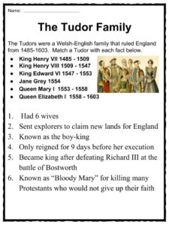
The Tudor Family
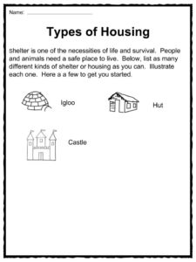
Types Of Housing
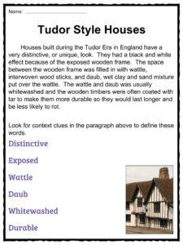
Tudor Style Houses
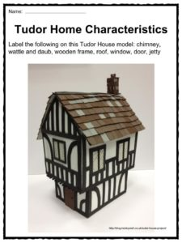
Tudor Home Characteristics

