**Significant Figure:** Emperor Hadrian

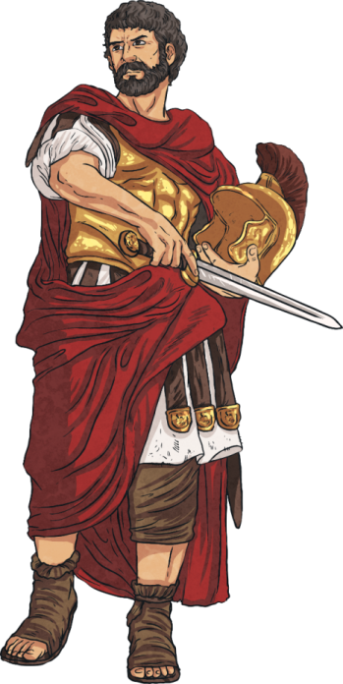

**Significant Figure:** Emperor Hadrian



**Significant Figure:** Emperor Hadrian



**Significant Figure:** Emperor Hadrian



**Significant Figure:** Emperor Hadrian



**Significant Figure:** Emperor Hadrian

