[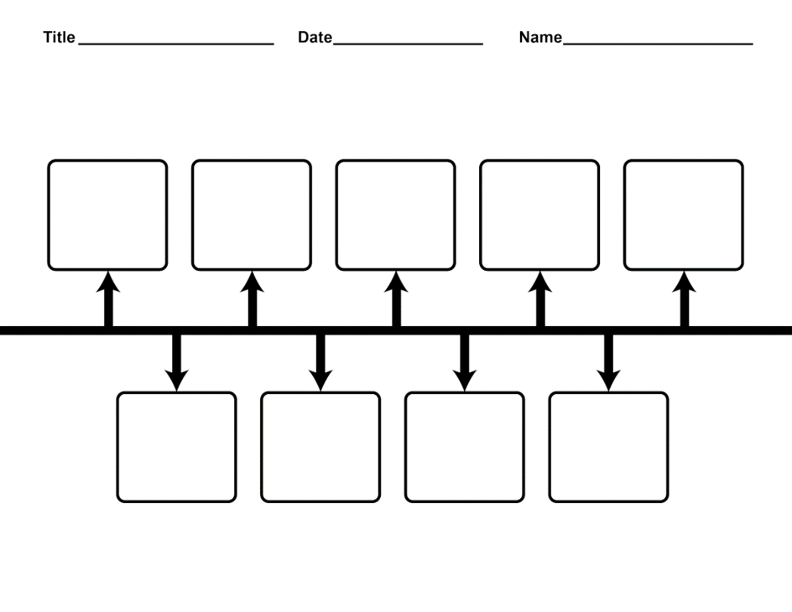](http://www.google.com/url?sa=i&rct=j&q=&esrc=s&source=images&cd=&cad=rja&uact=8&ved=2ahUKEwiKppOk8a7dAhViyoUKHfZtCXkQjRx6BAgBEAU&url=http://endlesswebsite.tk/printable-blank-timeline-template/&psig=AOvVaw0Z68h5XyOioL0KpNhJ-t4l&ust=1536615588177603)