**Reasoning**

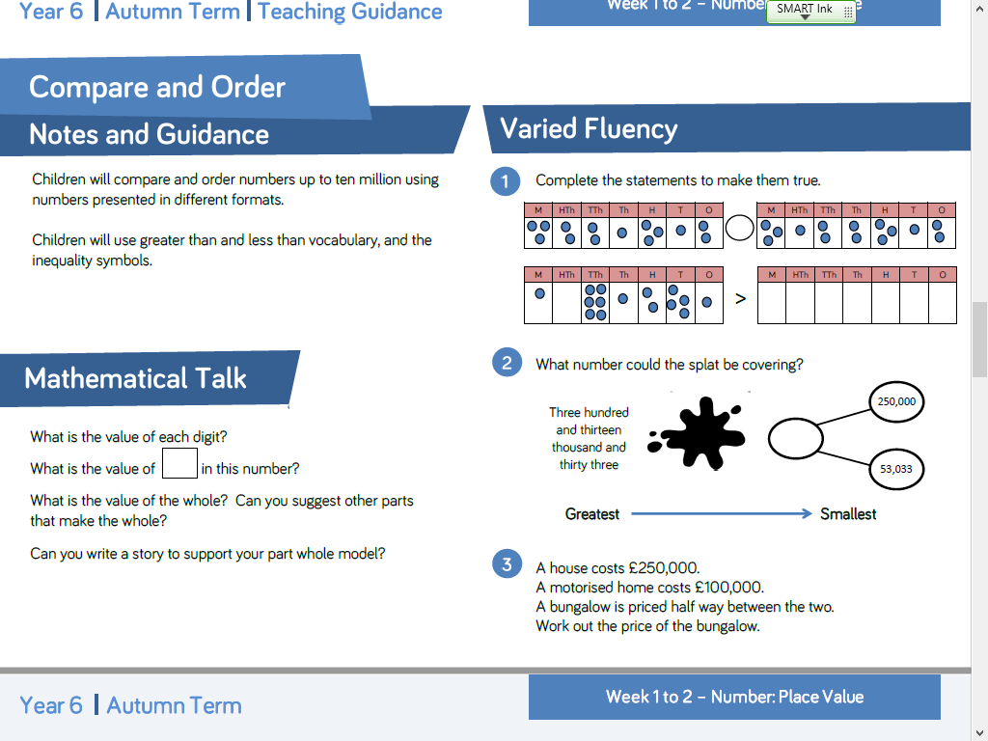

**Reasoning**



**Reasoning**



**Reasoning**

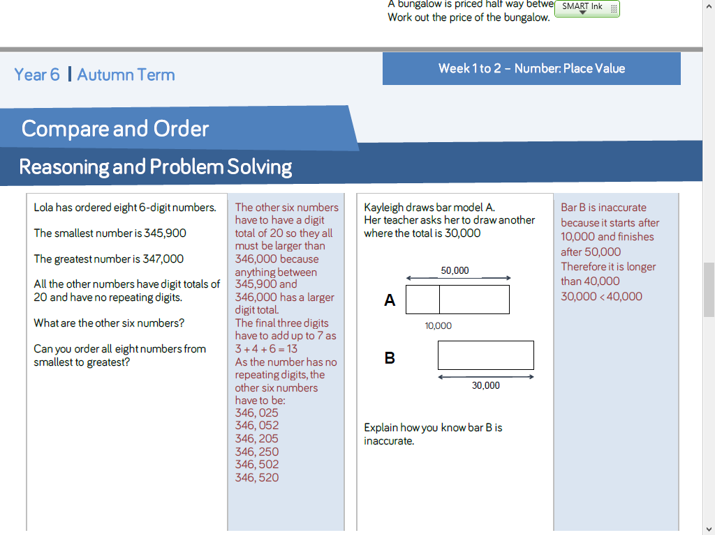

**Reasoning**

