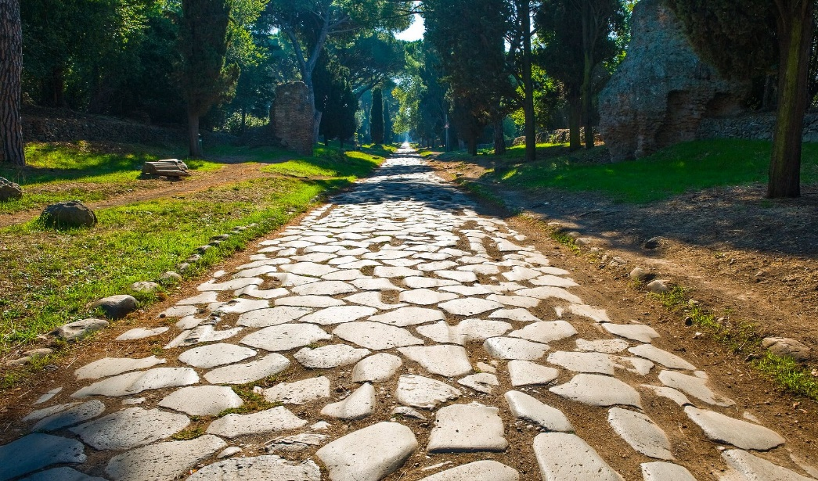

Why did the Romans build roads in Britain?

Why did the Romans build roads in Britain?

Why did the Romans build roads in Britain?