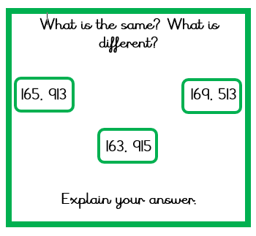

**What is the same? What is different?**

**165, 913 169, 513**

**163, 915**

**Explain your answer.**