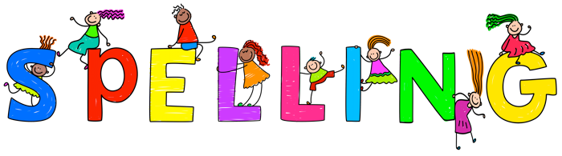

***Complete the sentences with the correct spellings:***

It was a windy day so we went to ----------- our kite in the -----.

I wanted to ---------- and do it myself but my brother started to ----- so I had to help him.

We are learning to ------------- 2 digits together.

_____________________________________________________________________________

_____________________________________________________________________________

***Circle the correct spelling:***

1. clime clibme climb
2. hase has hese