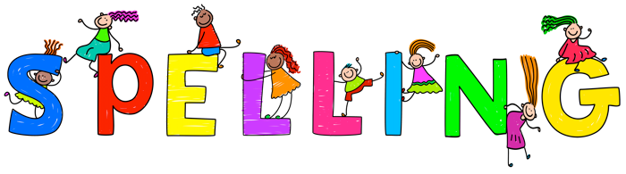

***Complete the sentences with the correct spellings:***

We went _____________ through the woods to the __________ part so that we could have a picnic. The sun was _________ so it was not _________.

_____________________________________________________________________________

_____________________________________________________________________________

***Circle the correct spelling:***

1. diden’t didn’t did’nt
2. fire fiyer fier