The Romans built the first roads in Britain. They built over 9,000 kilometres of roads. The roads were so well built that you can still see some of them today, 2000 years after they were first built!
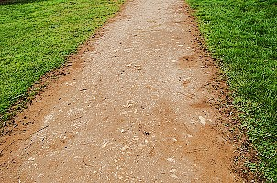
Roman Road in Cambridgeshire
Many of our modern day roads are in the same place as Roman ones. You can tell if it is Roman road because it will be straight.
Why did the Romans build roads?
It was important for the Roman army to be able to move soldiers and all their baggage around the country.
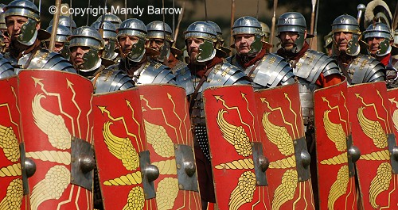
Why did the Romans build straight roads?
They built roads as straight as possible, in order to travel as quickly as they could. Winding roads took longer to get to the place you wanted to go and bandits and robbers could be hiding around bends.
How did people in Roman times travel around?
People would either ride on horseback, drive carts pulled by oxen, or walk.
Why were the roads built on a slant?
Roman roads sloped down from the middle to ditches on either side to allow the rain to drain away and not make the road too muddy.
How to build a Roman Road
- A surveyor, using a groma, made sure that the land was level and marked out the road with wooden stakes.
- An earthen bank, called an agger, was built up to 12 metres wide. The road surface was laid on top of this.
- Six to 12 inches (15 - 50 cm) of flint, gravel, stone slabs, or any other hard material available, was laid onto of the agger.
- A ditch was dug on either side for drainage.
The Groma
A groma was a wooden cross with weights hanging from it which gave the Romans a straight line.
