Revisit: Year 4 Electricity

Explain why this bulb will not light up.

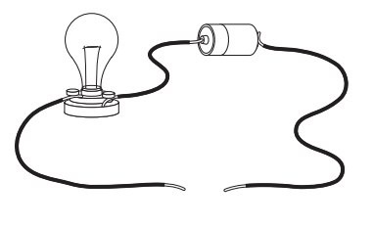

Revisit: Year 4 Electricity

Explain why this bulb will not light up.

