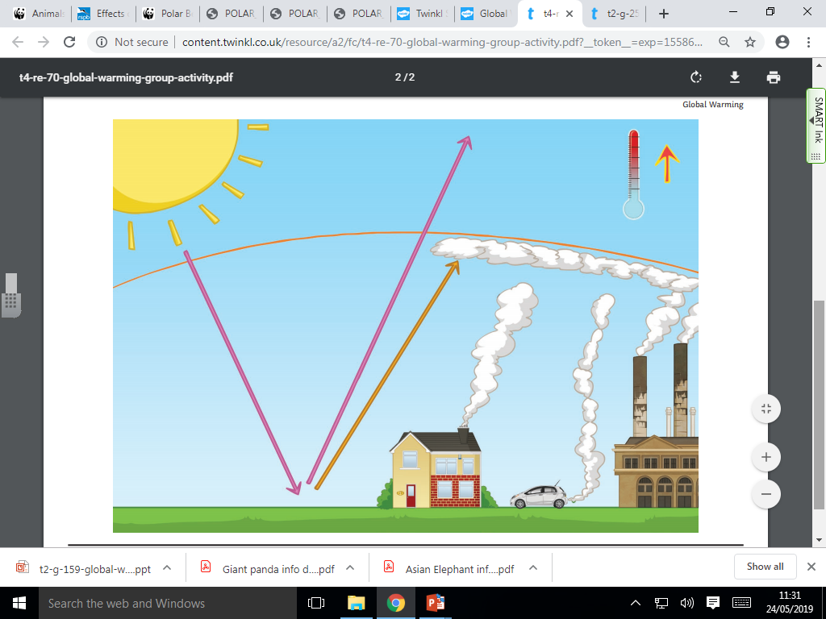**Green house effects**

**What happens to the heat produced by the Sun?**

**Can you describe the activities on Earth that are causing global warming?**

**Name some of the greenhouse gasses:**

**What is happening to the Earth’s temperature and why?**