Scientific Reasoning

Daisy and Rema make this circuit.
They close the switch but the electricity does not flow.
The bulb does not light.
The electrical wires are connected properly.
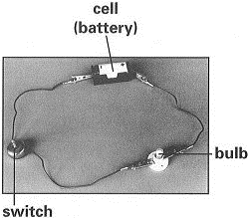
Give TWO possible reasons why their circuit does not work when they close the switch.

Scientific Reasoning

Daisy and Rema make this circuit.
They close the switch but the electricity does not flow.
The bulb does not light.
The electrical wires are connected properly.
Give TWO possible reasons why their circuit does not work when they close the switch.

