Ourselves MTP

 | Week 1 | Week 2 | Week 3 | Week 4 | Week 5 | Week 6 | Week 7
Literacy  Key texts:  Whatever next  Harry and the dinosaurs go to school  Lima’s red-hot chilli  Peace at last  Goldilocks and the three bears | Children to start  Staggered intake  6 new children per day  BASELINE ASSESMENTS  Book assessments  Assessment booklet  Observations | Writing  Focus text:  Whatever next  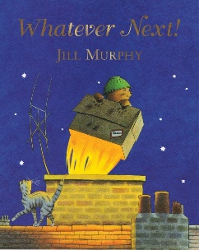  My rocket adventure  What would you take to the moon?  Children to draw, mark make/write words to label objects. | Reading  Focus text:  Harry and the dinosaurs go to school  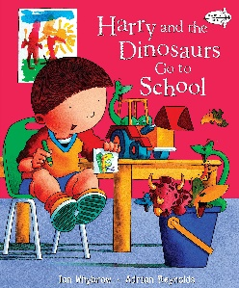  Children to listen to the story and re call key events. Children to illustrate their understanding.  Focus: initial sounds m and s | Writing  Focus text:  Lima’s red-hot chilli  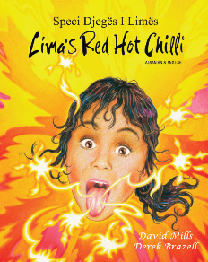  Children to recall the family members in the story and their actions. Children to label/mark make. | Reading  Focus text:  Peace and last  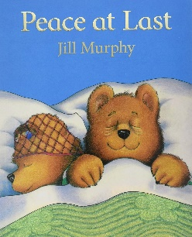  Children to recall and sequence images from the story. Children to label/mark make. | Writing  Focus text: Goldilocks and the three bears  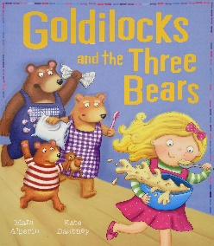  Children to make porridge and write a shopping list of ingredients used. | Reading  Focus text: Goldilocks and the three bears  Children to recall and match the 3 bears to objects in the story.  Phonics/HF word assessments
Numeracy |  | One, two, three  Children to be taught to count forwards and backwards 1-3  They count up to identical objects in different/same arrangements by touching each object as they count, saying the names in a stable order. | One, two, three  Children to be taught to count forwards and backwards 1-3  They count up to 3 different objects in different /same arrangements by touching each object as they count, saying the names in a stable order. | Four  Children can continue to apply the counting principles when counting to four (forwards and backwards).  They can represent four in different ways and count out four objects from a larger group. | Five  Children to continue to learn to count forwards and backwards accurately using the counting principles. They represent up to 5 objects on a five frame and understand that if the frame is full then there are 5 | Sorting into groups  Children learn that collections of objects can be sorted into sets based on attributes such as size and colour.  They begin to understand that the same collection of objects can be sorted in different ways and should be encouraged to come up with their own criteria for sorting objects into sets. | Comparing quantities of Identical objects  When comparing 2 groups children should be encouraged to line the items to make direct comparisons. Using 5 frames can support this.  They should also be encouraged to count each set carefully which helps them to link names of numbers, their value and their position in the counting order  Mini maths assessment
KUOW | Ourselves  LO: To identify own facial features | Our family  LO: To identify members of my family. | Our body  LO: To identify our body parts and explain how we use them | 5 senses  LO: To identify and use our 5 senses | Our Local Environment  LO: To identify features of our local environment | Homes around the World  LO: To identify different types of houses, and compare this to our home | Seasons  LO: To identify signs of autumn
PSHE | Classroom Rules and Behaviour Boundaries  Lo: To be aware of the classroom rules and say why they are important. | Intrducing Ourselves  LO: To idenitfy the person /people I love the most and say why | Basic hygiene  LO: To understand how to keep ourselves clean and safe | My Favourite Things are…  LO: To express my own likes and dislikes. | Feelings  Lo: To understand  that hands can be can be used to help or hurt others. | Feelings  Lo: To recognise a  range of different  feelings? | Changes  LO: To identify  some of the ways  I have grown since birth.
PD | Climbing and balancing on the outdoor obstacle course  Holding a pencil correctly | Using the bikes effectively  Fine motor- threading | Balancing and climbing on outdoor wooden play frame  Fine motor completing patterns | Moving in a range of ways:  slithering, shuffling, rolling, crawling, | Moving in a range of ways:  walking, running, jumping, skipping, sliding and hopping. | Throwing and catch a ball | Bean bag and hoop matching
Art |  |  | 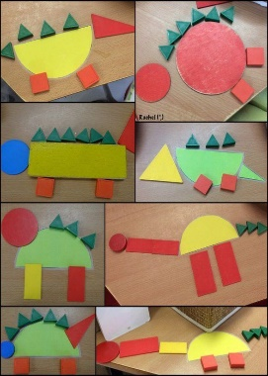 | 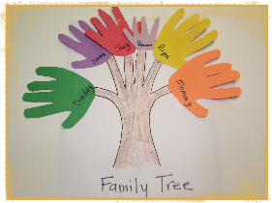 | 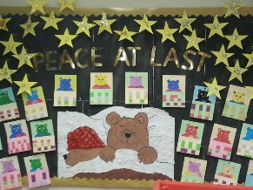 |  | 