**What was life like for the those in the workhouses?**

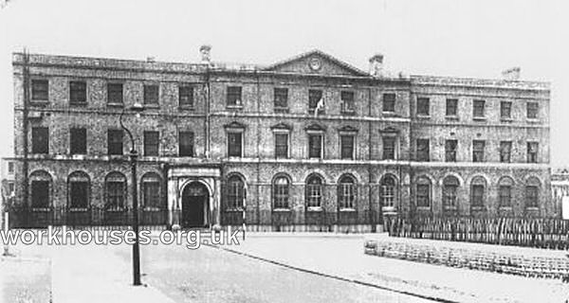

**What were the workhouses**

**________________________________________________________________________________________________________________________________________________________________________________________________________________________________________________________________________________________________________________________________________________________________**

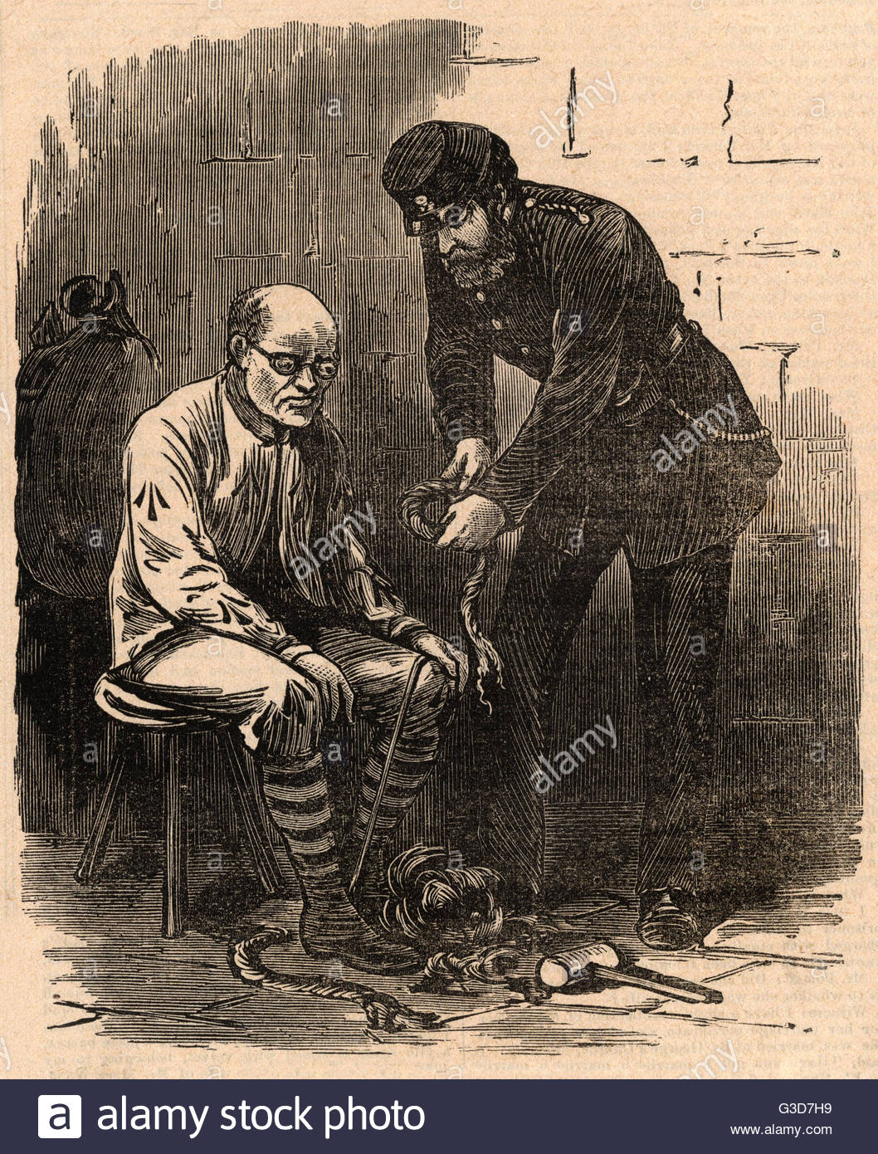

**Jobs**

**________________________________________________________________________________________________________________________________________________________________________________________________________________________________________________________________________________________________________________________**

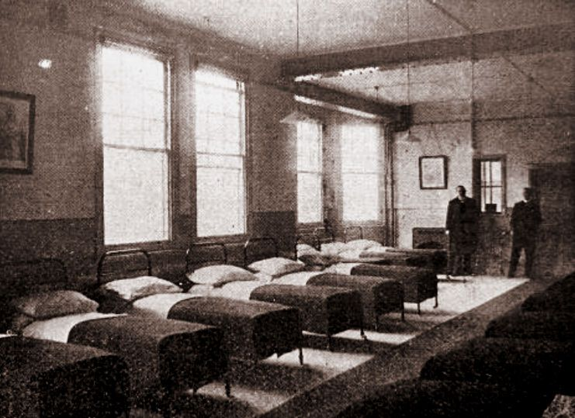

**Dormitories (How people were separated and slept)**

**________________________________________________________________________________________________________________________________________________________________________________________________________________________________________________________________________________________________________________________________________________________________**