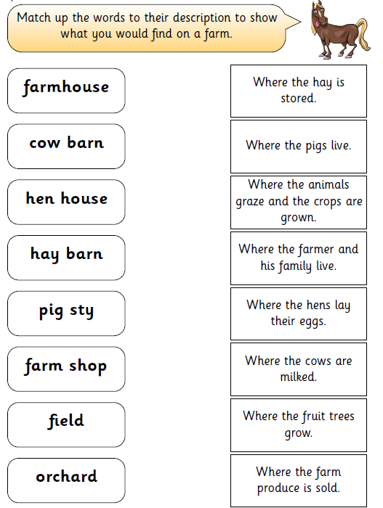

Monday 28th September 2020

LO: To identify the features of a farm