09.09.20
To count amounts
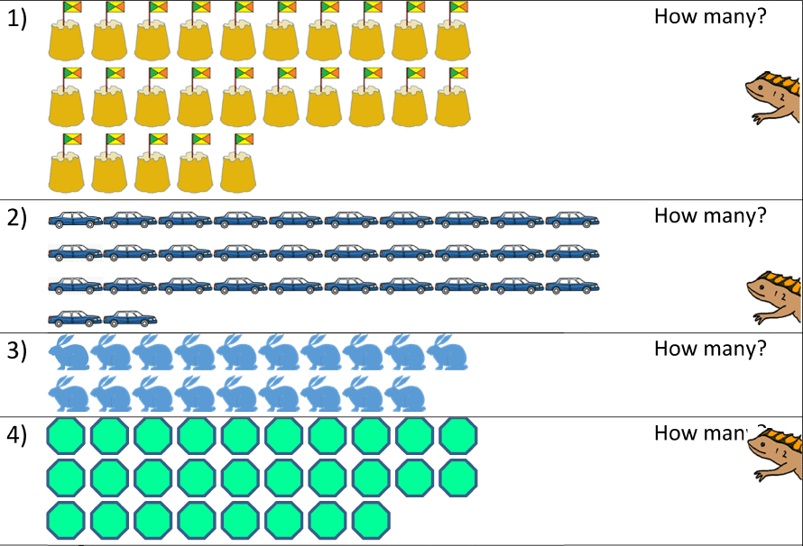

How did you count the objects?

