**Copy and complete these sentences in your books**

1. Grace was a girl who loved (her family / books / stories).

2. Grace didn’t mind if her stories were from books or (in the cinema / out of Nana’s long memory).

3. After she heard stories Grace would (fall asleep / ask for another story / act them out).

4. Grace always gave herself the most (exciting / scary / fun) part.

5. List 3 characters Grace enjoyed playing.

Grace played _____________________

6. Why do you think she liked these parts?

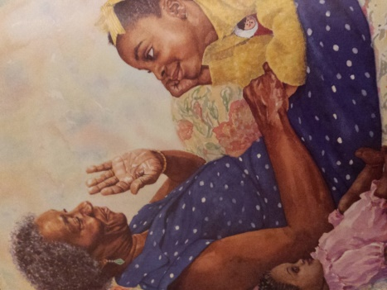

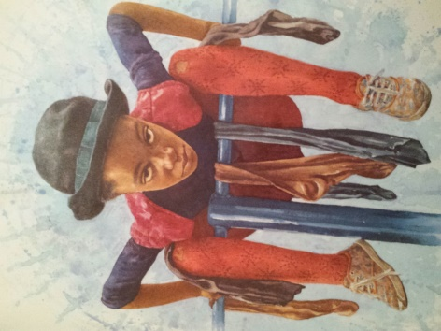

**Copy and complete these sentences in your books**

1. Grace was a girl who loved (her family / books / stories).

2. Grace didn’t mind if her stories were from books or (in the cinema / out of Nana’s long memory).

3. After she heard stories Grace would (fall asleep / ask for another story / act them out).

4. Grace always gave herself the most (exciting / scary / fun) part.

5. List 3 characters Grace enjoyed playing.

Grace played _____________________

6. Why do you think she liked these parts?

