Memory

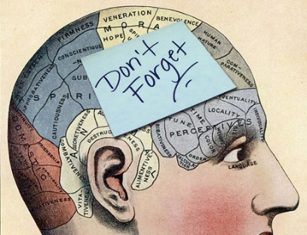

Wove

[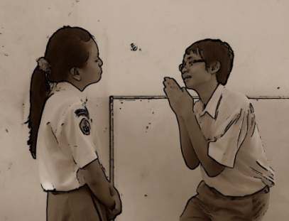](http://www.google.co.uk/url?sa=i&source=images&cd=&cad=rja&uact=8&docid=Jxo4Wqz6d1rF4M&tbnid=SF33735eCrHKXM&ved=0CAgQjRw&url=http://meryanggrinaprimbon.blogspot.com/2012/11/persuading-and-encouraging-preventing.html&ei=YEj6U7nVLJbXav-fgfgP&psig=AFQjCNHsRvT7D6aLC6yvK1ub8McZntzilw&ust=1408997856803019)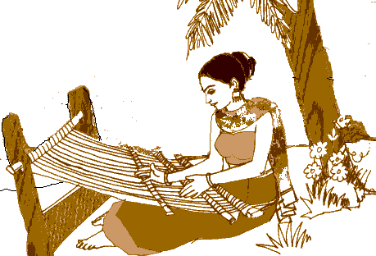

A play for children with singing and jokes

To have made by twisting and turning

To make someone believe something is worth doing

Something that is remembered

Pantomime

Persuade