1. At school Grace’s teacher said they were going to do the play of (Hiawatha / Jungle book / Peter Pan).

2. Grace wanted to play the part of (Mowgli / Captain Hook / Peter Pan).

3. Why does Raj say she can’t play the part?

4. Do you think Raj is being fair to Grace by saying this? Why?

5. Grace still keeps her hand up. Why doesn’t she put it down again?

6. What do you think will happen next? Start with ‘I predict_________________ ‘

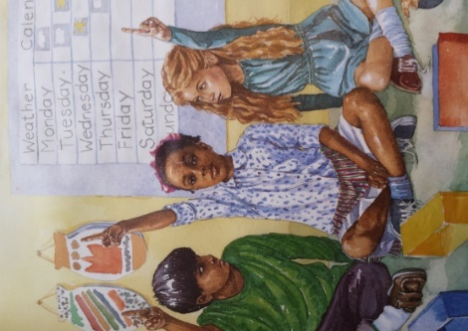

Copy and complete **these sentences in your books.**

**Remember full stops and capital letters!**

1. At school Grace’s teacher said they were going to do the play of (Hiawatha / Jungle book / Peter Pan).

2. Grace wanted to play the part of (Mowgli / Captain Hook / Peter Pan).

3. Why does Raj say she can’t play the part?

4. Do you think Raj is being fair to Grace by saying this? Why?

5. Grace still keeps her hand up. Why doesn’t she put it down again?

6. What do you think will happen next? Start with ‘I predict_________________ ‘

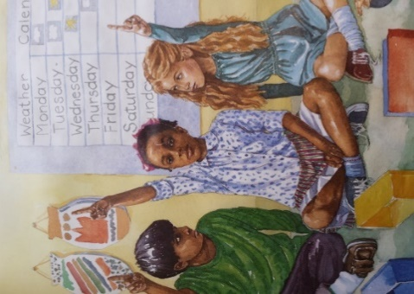

**Copy and complete these sentences in your books.**

**Remember full stops and capital letters!**