1. On Saturday Nana took Grace to (a grand theatre / a pantomime).

2. Nana showed Grace a photograph of a young (dancer / actress).

3. Why did Nana show Grace the photograph of the ballerina?

4. Look at the illustration of Grace dancing in a tutu. How does she feel now? How do you know?

5. What did Grace think to herself as she danced?

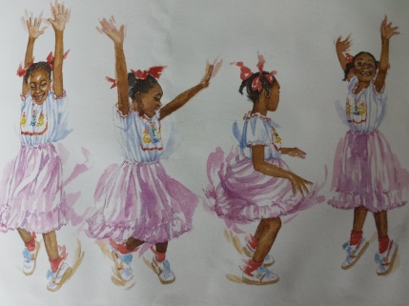

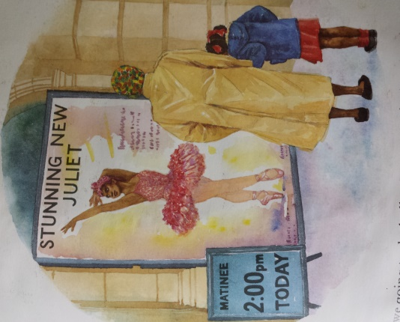

**Answer these questions using full sentences. Try and use ‘because’.**

1. On Saturday Nana took Grace to (a grand theatre / a pantomime).

2. Nana showed Grace a photograph of a young (dancer / actress).

3. Why did Nana show Grace the photograph of the ballerina?

4. Look at the illustration of Grace dancing in a tutu. How does she feel now? How do you know?

5. What did Grace think to herself as she danced?





**Answer these questions using full sentences. Try and use ‘because’.**