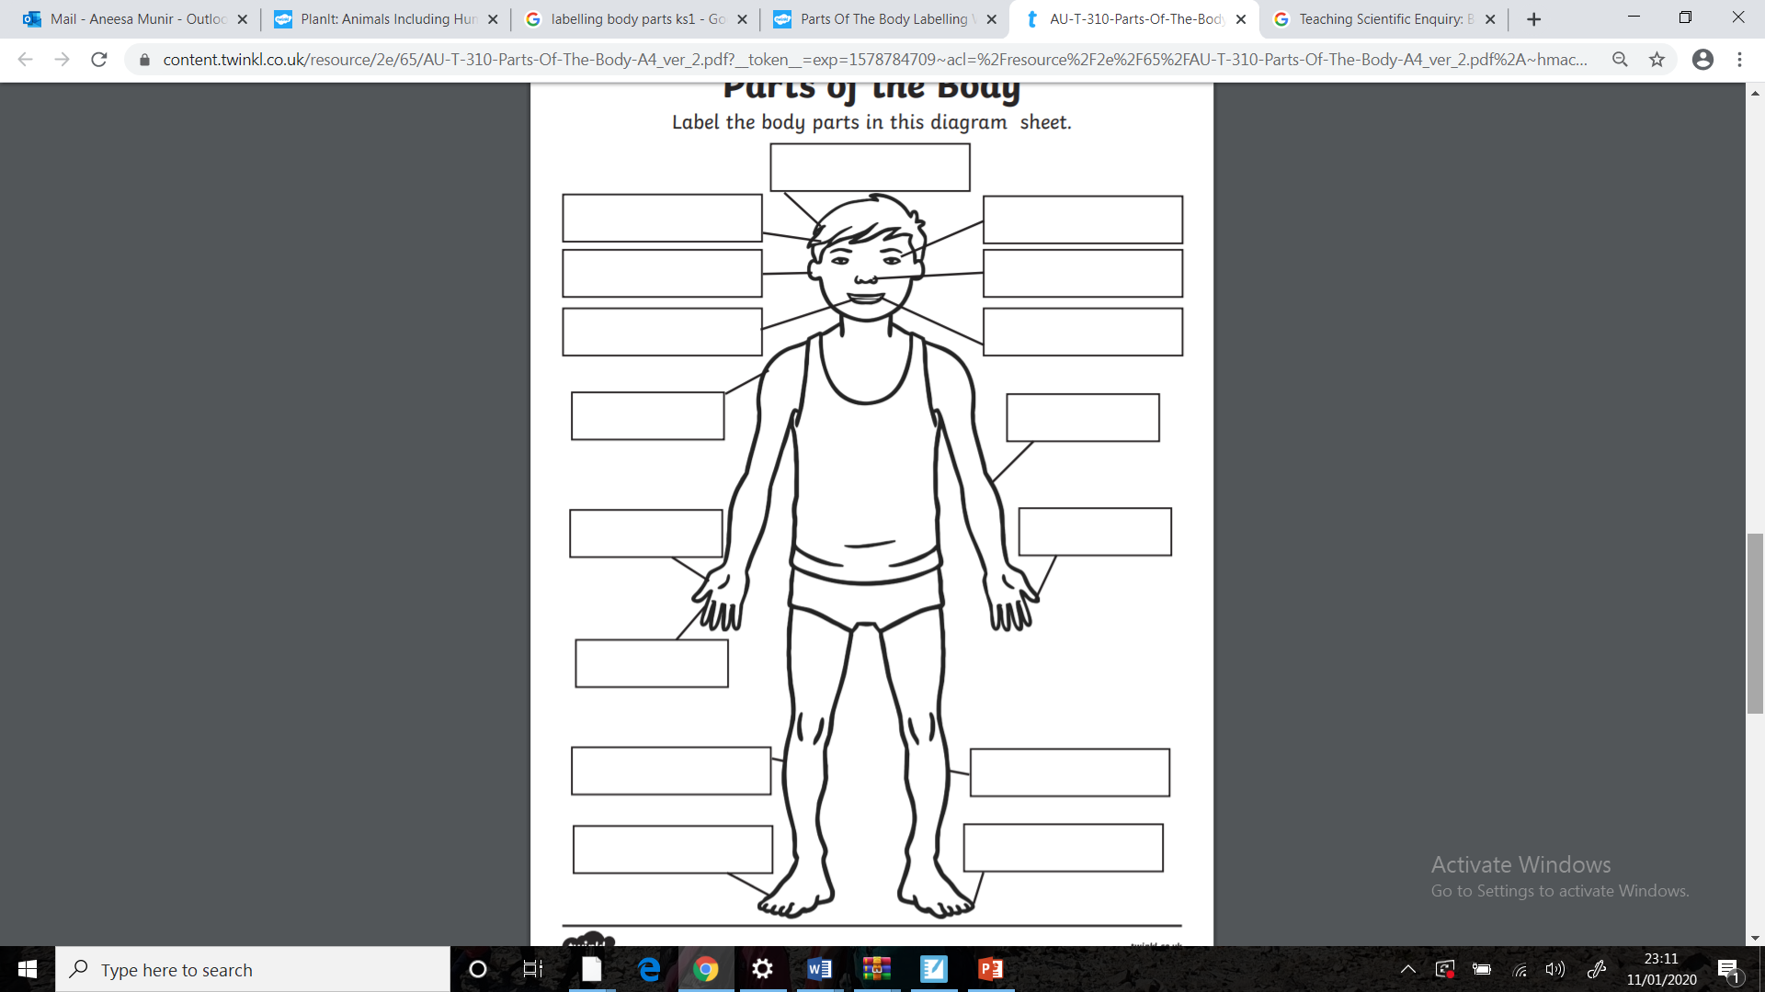

**Enquiry Question**

What part of the body is important but can’t be seen?