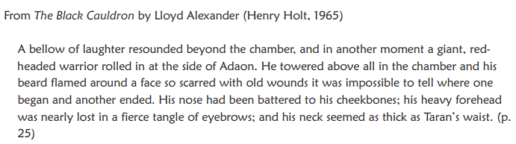

Key:
Vivid adjectives, verbs and nouns
Expanded noun phrases
Alternative sentence starters
Complex sentences
Punctuation for parenthesis
Figurative device/s

