Wednesday 22nd January 2020

LO: To investigate whether there is a correlation between hand and foot size

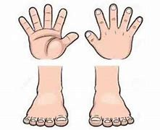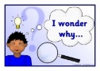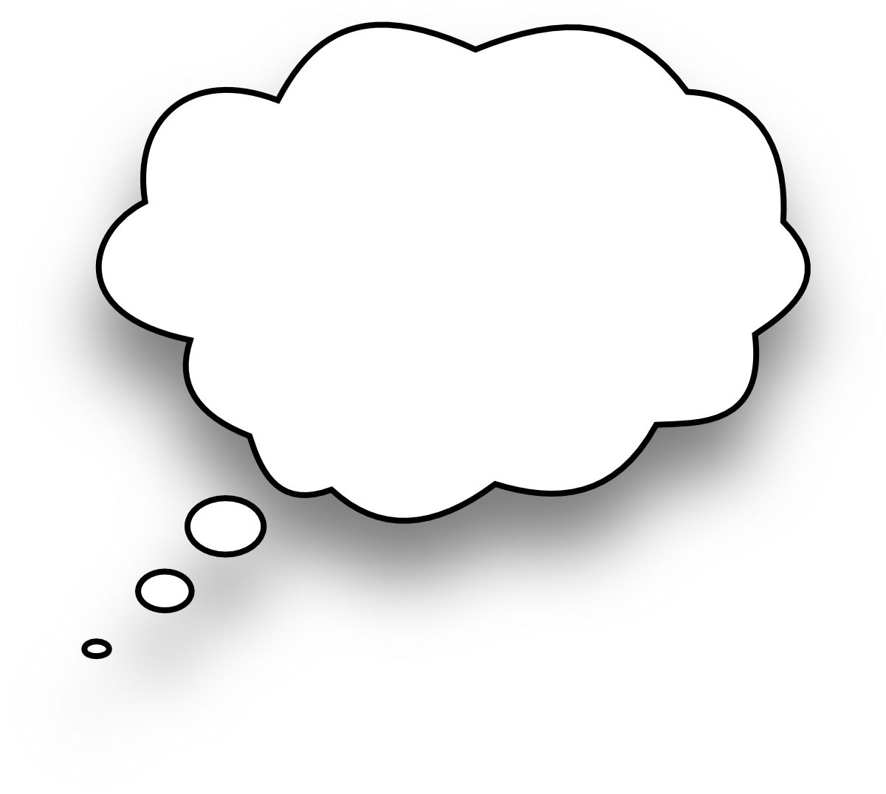

**Enquiry Question**

If someone has big feet, do they also have big hands?

Aim:

Prediction:

Equipment:

**Tick the correct one**

Big feet and big hands

Big feet and small hands

Aim: To investigate if people with ………………

hands also have ……………… feet.