Hadrian's Wall
Unlike the rest of Britain, Scotland was never considered part of the Roman Empire. The Roman armies invaded Scotland several times and even defeated the northern tribes a few times, but they never controlled Scotland.
Defending their Empire
To control their newly won territory in England, the Romans built heavily defended forts around the country. Most famous of all, on the northern edge of their British territory, the Romans built a coast-to-coast wall to protect Roman England from the tribes who lived in Scotland.

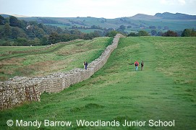
Hadrian's Wall was built so well, that you can still go and see parts of it today, nearly 2000 years after it was made.
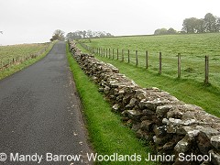
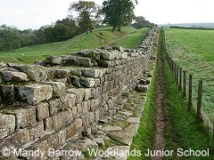
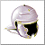What was Hadrian's Wall?
Hadrian's Wall was a stone barrier built to separate the Romans and the Picts tribes in Scotland. It allowed Roman soldiers to control the movements of people coming into or leaving Roman Britain.

The remains of a turret
During the building of the Wall, it was decided to add forts. There were 16 forts in total along the length of the Wall. These meant that even more Roman soldiers were based along the wall and the frontier was more effectively controlled.
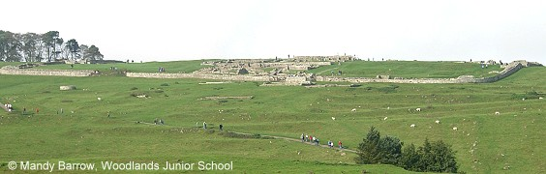
Housesteads (Vercovicium) Roman Fort
Housesteads is the best-known fort on Hadrian,s Wall. It covers 5 acres (2 hectares).
How long was Hadrian's Wall?
It was 117 kilometers (73 miles) long across the narrow neck of England, from the North Sea to the Irish Sea. (see map)
How wide and high was Hadrian's Wall?
The wall was eight to ten feet wide and fifteen feet high.
When did the Romans build Hadrian's Wall?
The Romans began building the wall in 122 A.D.
Why did the Romans build Hadrian's Wall?
The Romans built it because they were afraid that the people of the north might attack them. The wall was built between Roman Britain and Scotland.
How long did it take to build Hadrian's Wall?
It took about 14 years to complete Hadrian's Wall. The largest structure ever made by the Romans.
Who built Hadrian's Wall?
Hadrian’s Wall was built on the orders of the Roman emperor Hadrian. It was constructed by three legions of soldiers.
Who was Emperor Hadrian?
Hadrian was born in Rome in A.D. 76. He became Emperor of Rome in A.D. 117 and ruled for 21 years until A.D. 138.
Hadrian came to visit Britain in A.D. 122, one of the many stops on a tour of the western provinces of the Roman Empire. His mission was to strengthen the defences along the northern Roman Empire. It is likely that during this visit that he ordered the construction of the Wall.

Roman Britain - Hadrian's Wall
1. Emperor Hadrian visited Britain in AD 122.
2. He ordered that a wall should be built between the Solway Firth and the River Tyne.
3. Hadrian’s Wall was built to provide a defensive barrier that guarded the northern frontier from barbarian invaders.
4. Hadrian’s Wall controlled the movement of people coming into, or leaving Roman Britain.
5. The wall was built by Roman soldiers so that they would keep fit and busy when not fighting.
6. The majority of Hadrian’s Wall was built of stone, but some sections were made of turf.
7. It took six years to build Hadrian’s wall.
8. The wall was eighty (Roman) miles long, six metres high and three metres wide with a walkway on top.
9. On north side of the wall, there was a deep, wide ditch and on the south a smaller ditch and a military road.
10. Milecastles were placed at regular intervals along Hadrian’s Wall, so named as they were built every Roman mile.
11. Each pair of milecastles had two turrets between them.
12. Milecastles could garrison between eight and thirty-two men.
13. Turrets were about nine metres high.
14. They provided observation points and shelter for Roman soldiers on duty patrolling the wall.
15. The turrets had two storeys, one for cooking and one for sleeping.
16. As it developed, more Roman legionaries moved up to the wall and large forts were built.
17. The forts had large gates, with stone towers on either side, to allow traffic to pass through.
18. There were seventeen forts along Hadrian’s Wall, each housing between five hundred and one thousand men.
19. The forts included the headquarters, barracks, a commander’s house, granaries, hospital and toilets.
20. Roman soldiers garrisoned on the wall came from all across the Empire.
21. Small towns grew up around the forts.
22. Hadrian’s Wall was occupied for three centuries and was home to thousands of men, women and children.
23. Hadrian’s Wall was an impressive monument to Roman occupation of Britain.

