Hadrian's Wall
Unlike the rest of Britain, Scotland was never considered part of the Roman Empire. The Roman armies invaded Scotland several times and even defeated the northern tribes a few times, but they never controlled Scotland.
Defending their Empire
To control their newly won territory in England, the Romans built heavily defended forts around the country. Most famous of all, on the northern edge of their British territory, the Romans built a coast-to-coast wall to protect Roman England from the tribes who lived in Scotland.

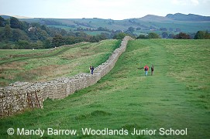
Hadrian's Wall was built so well, that you can still go and see parts of it today, nearly 2000 years after it was made.
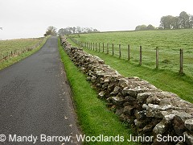
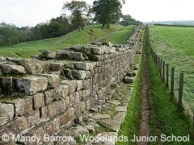
What was Hadrian's Wall?
Hadrian's Wall was a stone barrier built to separate the Romans and the Picts tribes in Scotland. It allowed Roman soldiers to control the movements of people coming into or leaving Roman Britain.

The remains of a turret
During the building of the Wall, it was decided to add forts. There were 16 forts in total along the length of the Wall. These meant that even more Roman soldiers were based along the wall and the frontier was more effectively controlled.
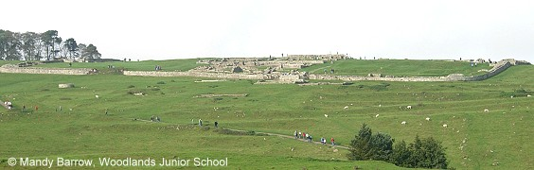
Housesteads (Vercovicium) Roman Fort
Housesteads is the best-known fort on Hadrian,s Wall. It covers 5 acres (2 hectares).
How long was Hadrian's Wall?
It was 117 kilometers (73 miles) long across the narrow neck of England, from the North Sea to the Irish Sea. (see map)
How wide and high was Hadrian's Wall?
The wall was eight to ten feet wide and fifteen feet high.
When did the Romans build Hadrian's Wall?
The Romans began building the wall in 122 A.D.
Why did the Romans build Hadrian's Wall?
The Romans built it because they were afraid that the people of the north might attack them. The wall was built between Roman Britain and Scotland.
How long did it take to build Hadrian's Wall?
It took about 14 years to complete Hadrian's Wall. The largest structure ever made by the Romans.
Who built Hadrian's Wall?
Hadrian’s Wall was built on the orders of the Roman emperor Hadrian. It was constructed by three legions of soldiers.
Who was Emperor Hadrian?
Hadrian was born in Rome in A.D. 76. He became Emperor of Rome in A.D. 117 and ruled for 21 years until A.D. 138.
Hadrian came to visit Britain in A.D. 122, one of the many stops on a tour of the western provinces of the Roman Empire. His mission was to strengthen the defences along the northern Roman Empire. It is likely that during this visit that he ordered the construction of the Wall.

Roman Baths (Thermae)
Every town had its own bath complex (like a large swimming pool). There were 170 baths in Rome during the reign of Augustus and by 300 A.D that number had increased to over 900 baths.
The Romans loved washing and bathing and rather it being done in private, the Romans built magnificnt public bath houses in towns across their empire. Rich villa owners would had their own baths in their homes.
You can see remains of a Roman bath in the city of Bath, in Somerset.
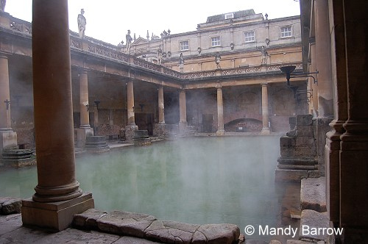
Roman bath in the city of Bath
Baths were not only places for washing.
People went to the public baths for entertainment, healing or just to get clean. Some people went to the public baths to meet friends and spend their spare time there. Large bath houses had restaurants games rooms snack bars and even libraries.
The baths were very luxurious.
The average bath housewould have mirrors covering the walls, ceilings were buried in glass and the pools were lined with rich marble and complicated mosaics covered the floors.
The baths had their own constant supply of fresh water
In some places like Bath in Somerset a natural spring provided the bath with its water. Other places the water was either piped in or brought to the town by an aqueduct. The water was heated by the central heating system similar to the ones Romans used in their homes, this was called a hypocaust system.

Visiting a Roman Bath
First you would take off your clothes in the changing room. Then you would relax in the warm room (called the Tepidarium). After the Tepidarium you would go into the hot room (called the Calarium). The steam in the room would make you sweat.
In the next room a slave would scrape off the sweat and dirt with a strigil. You would then jump into the cold bath (called the Frigidarium).
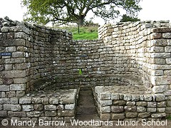
Remains of part of the Bath House at the Roman town of Chester
There were separate baths for men and women.

Aqueducts
Aqueducts were long channels that the Romans built to carry water into the cities. Many of the Roman aqueducts were below ground. The water that was carried into the cities was used for drinking water, baths, and sewers. It was generally carried to a public fountain where people could then use buckets to get their water. Roman plumbing became so advanced that many of the large wealthy houses had running water.
