Adélie Penguins

The Adélie Penguin lives along the coastline and the small islands of the Antarctic continent. It breeds in rocky, ice-free coastal areas. When the sea freezes in the winter, they travel north and forage in the open ocean. Warming of the air and ocean is causing a decline in the West Antarctic Peninsula colonies.
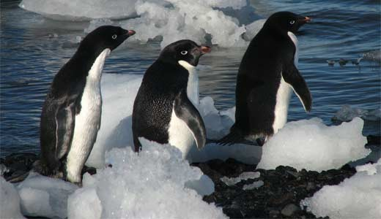

Amazing Facts About the Adélie Penguin
- Adélie Penguins are excellent swimmers and can dive to depths of up to 175 metres in search of prey. They forage for crustaceans, fish and squid in the Southern Ocean.
- Their black and white plumage provides good camouflage from predators, including leopard seals and killer whales, when foraging. Their black back blends into the dark ocean depths when viewed from above, and their white front blends into the bright sea surface when viewed from below.
- The Adélie Penguin is named after Adéle d’Urville, the wife of the French Antarctic explorer Dumont d’Urville.Share

How do Adélie Penguins breed?
- Adélie Penguins spend October to February (the Antarctic summer months) breeding in rocky, ice-free coastal areas. When the sea freezes in the winter, they travel north along the pack ice and forage in the open ocean.
- During the breeding season, the males arrive at the coastal breeding grounds first and begin building nests out of pebbles. The females arrive a few days later and after courtship, the male and female pair complete their nest together. Sometimes, adults will steal pebbles from other nests instead of finding their own construction materials.
- Females lay two eggs and both parents take turns incubating them for around 35 days. After hatching, the fluffy, clumsy chicks are very vulnerable to predation by giant petrels and skuas. At the age of three weeks, the chicks gather in small groups called crèches to protect themselves from predators and harsh weather, which allows both parents to resume foraging at the same time.

Conservation status of the Adélie Penguin
- The Adélie Penguin is classified as Near Threatened on The IUCN Red List of Threatened Species.
- Warming of the air and ocean is making the species’ habitat less suitable, causing a decline in the West Antarctic Peninsula
- Competition with commercial fisheries for fish and krill may also become a more significant threat to Adélie penguins as human population pressure continues to grow.

