To place numbers beyond 1000 onto a number line.

Fluency – Part 1 (find where the number should go)
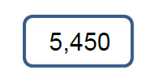
Draw an arrow to show where each number should go on the number line.

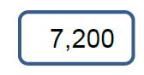

Fluency – Part 2 (Estimate the value)
Estimate the value of A, B and C on each number line.
