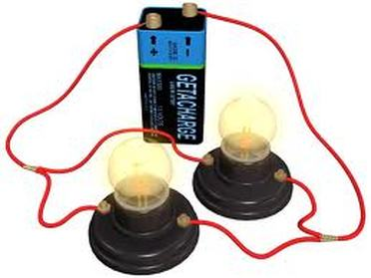

**Enquiry Question: How does the amount of voltage in a circuit affect the brightness of a bulb?**



**Enquiry Question: How does the amount of voltage in a circuit affect the brightness of a bulb?**



**Enquiry Question: How does the amount of voltage in a circuit affect the brightness of a bulb?**