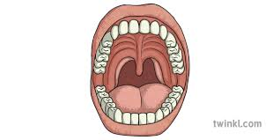

**Enquiry Question: What would happen if all animals had the same teeth?**



**Enquiry Question: What would happen if all animals had the same teeth?**



**Enquiry Question: What would happen if all animals had the same teeth?**



**Enquiry Question: What would happen if all animals had the same teeth?**