**Enquiry Question:**

How have **archaeologists** helped us understand how life was like in the Roman times?

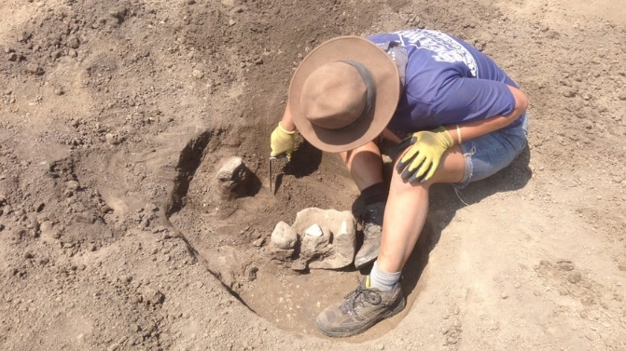

**Enquiry Question:**

How have **archaeologists** helped us understand how life was like in the Roman times?



**Enquiry Question:**

How have **archaeologists** helped us understand how life was like in the Roman times?

