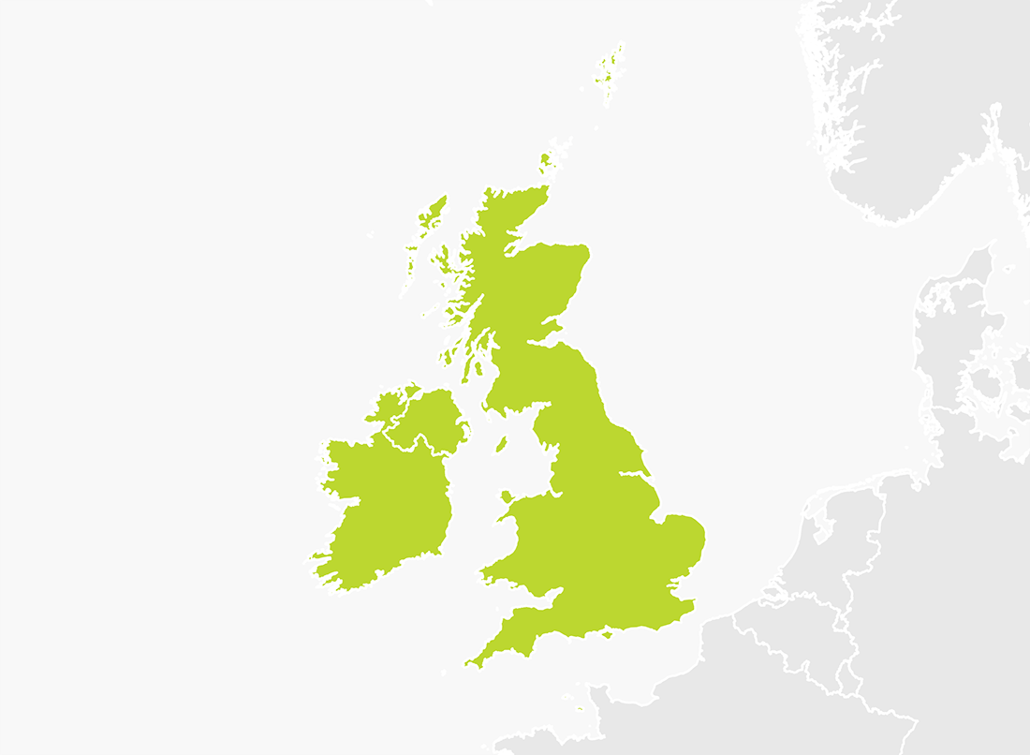

Starter – Revisit

Task: name and locate countries, cities and seas of the UK.

Starter – Revisit

Task: name and locate countries, cities and seas of the UK.